Star topology

In the Packet Tracer on the lower left corner, there are all the components required for creating our network. There are routers, switches, End devices, Hubs, Wireless Devices, and Connections etc.
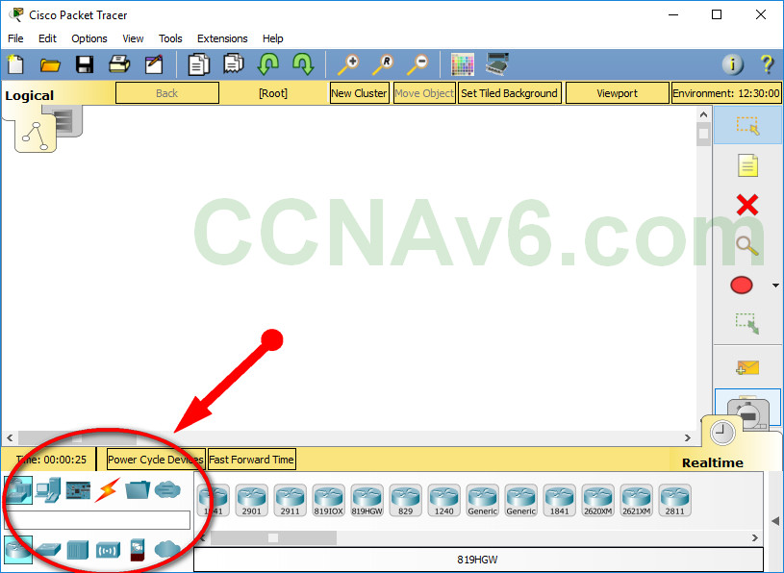

Click on “Hubs”. To the right, you should see types of hubs displayed. Use generic.

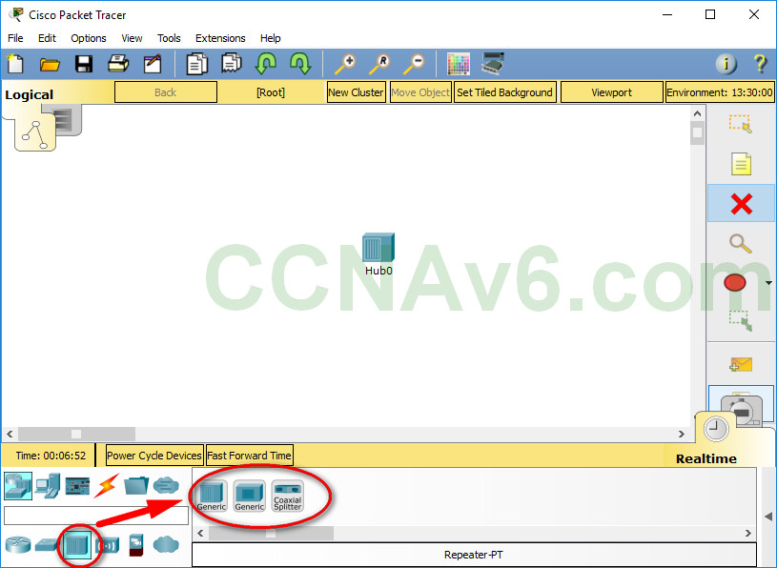

Click on the hub we just placed in our workspace. You are shown the physical view of the hub and it is a physical view literally.

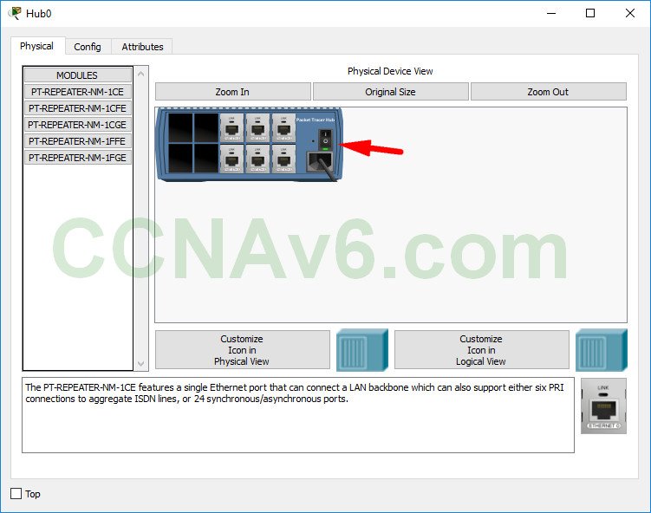

Click on the “Config” tab just beside the “Physical” tab. Change the display name of the hub from “Hub0” to “Hub”. Then close it.
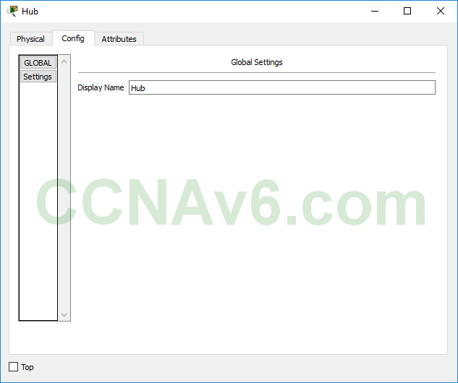

Now add five computers around the hub to form Hub and Spoke topology. Use generic.

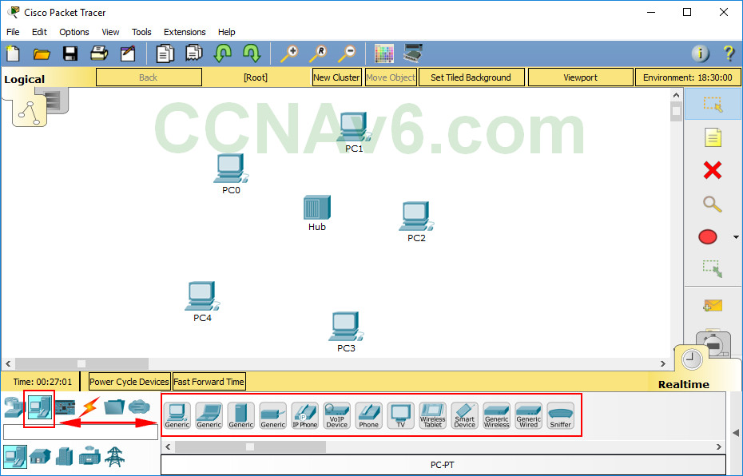

Click on “Server”. Go to “Config” tab. Here, we can configure Static IP address / Gateway / Subnet Mask. Click on the INTERFACE “FastEthernet0” to the left. Set IP configuration as static and give “IP address” as 192.168.0.254 and “Subnet Mask” as “255.255.255.0”.

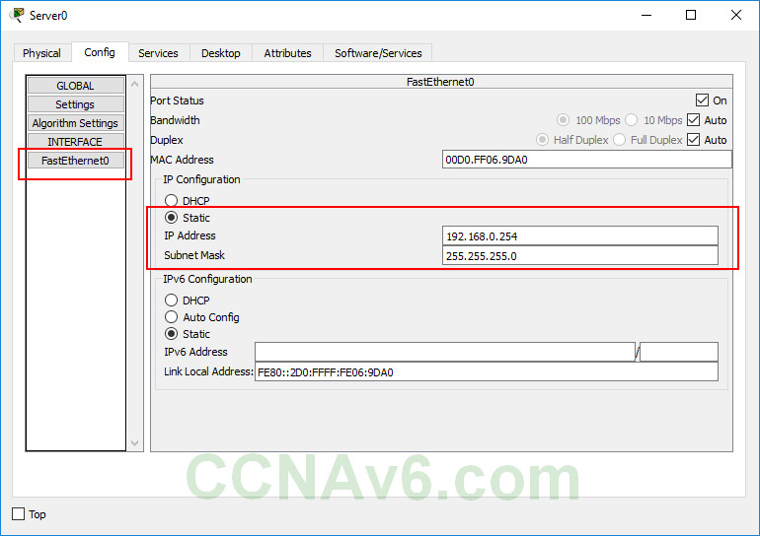

Click on the GLOBAL “Settings” to the left. Set IP configuration as static and give “Gateway” as 192.168.0.1 and “DNS Server” as “8.8.8.8”.

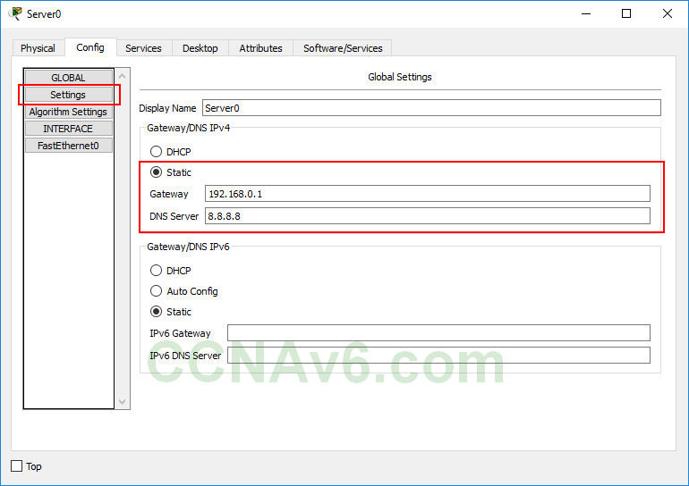
Click on the GLOBAL “Settings” to the left. Set IP configuration as static and give “Gateway” as 192.168.0.1 and “DNS Server” as “8.8.8.8”.

Go to “Services” tab. We can see the services which can be configured on our servers HTTP, DHCP etc etc. Click on “DHCP”. Keep the Pool Name, change Default Gateway and DNS server same. Give “Starting IP address” as “192.168.0.10” and “Subnet Mask” as “255.255.255.0” and “Maximum number of Users” as “150”. Turn On DHCP service if it is OFF. Click on “Save”. Close the window.
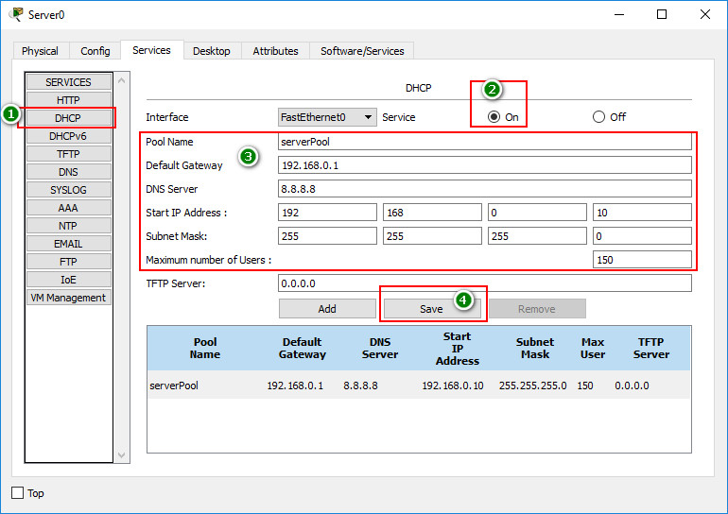
Now connections need to be done. In the components to the lower left corner, Click on “Connections”.
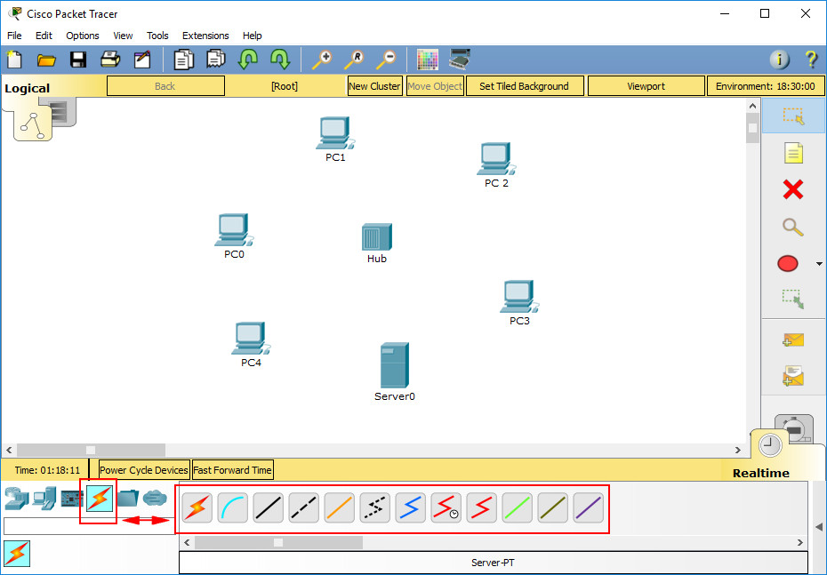

Click DHCP and wait until the DHCP request is successful.

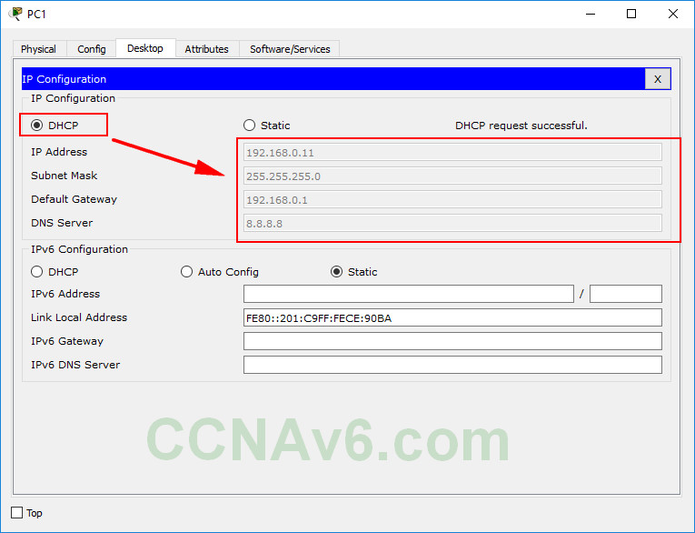

Now let’s see the functioning of the hub. Click on “Simulation” beside “Real-time” as shown below.
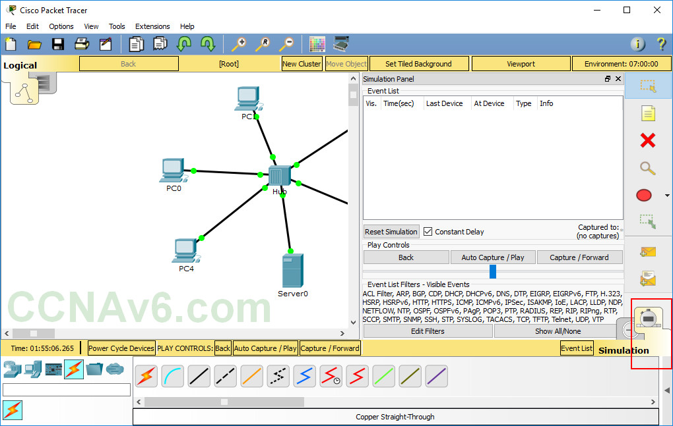
Now let us see how packets travel from PC0 to the Server we are trying to ping. Click on “Capture/ Forward” as shown below.
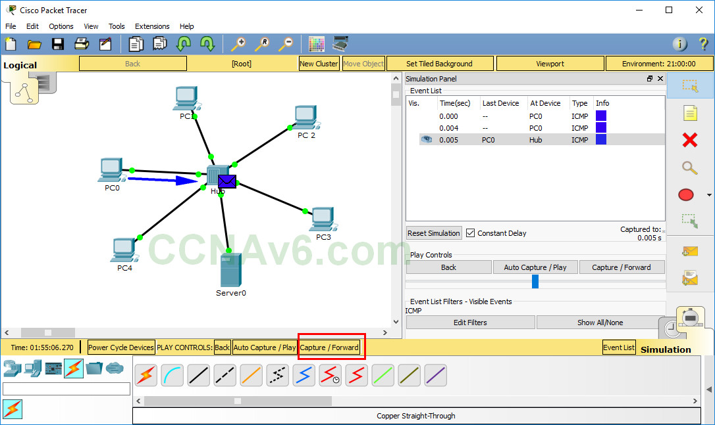
Click on “Capture/ Forward” again. The hub forwards the frame on all the ports, except the port through which the frame came in. All hosts except Server discard the frame since it is not addressed to them.
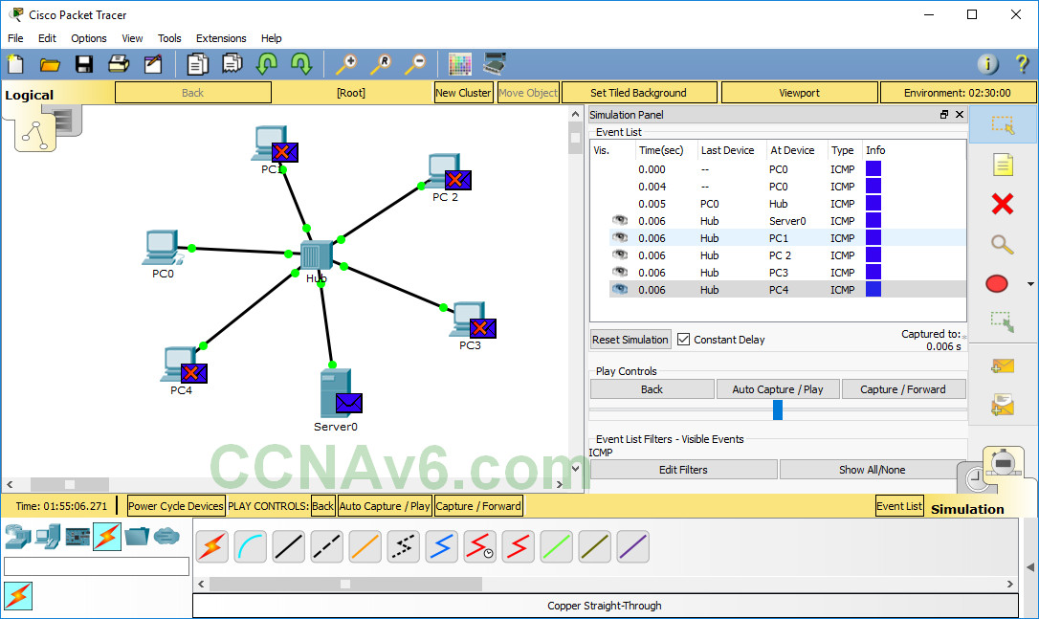

Click on “Capture/ Forward”. The server forwards a frame to the hub.

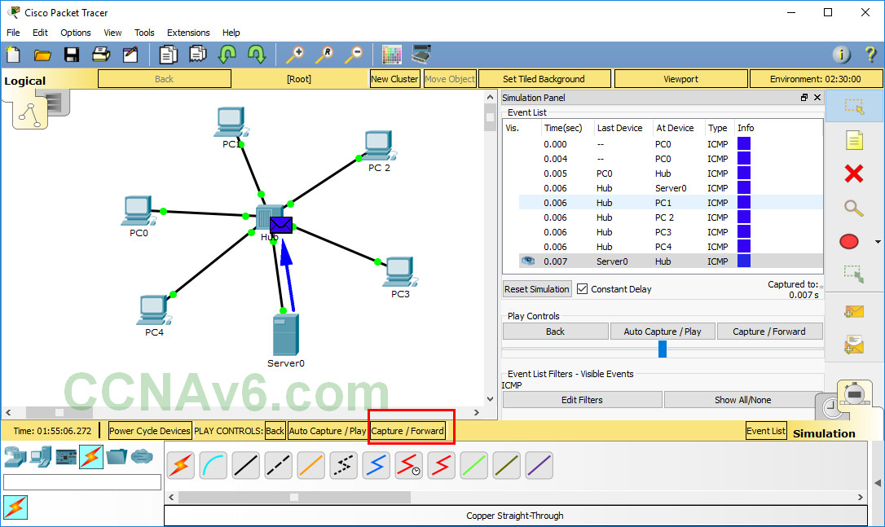

To see the list of complete events undergone in this communication, Click on “Event List” as shown below.

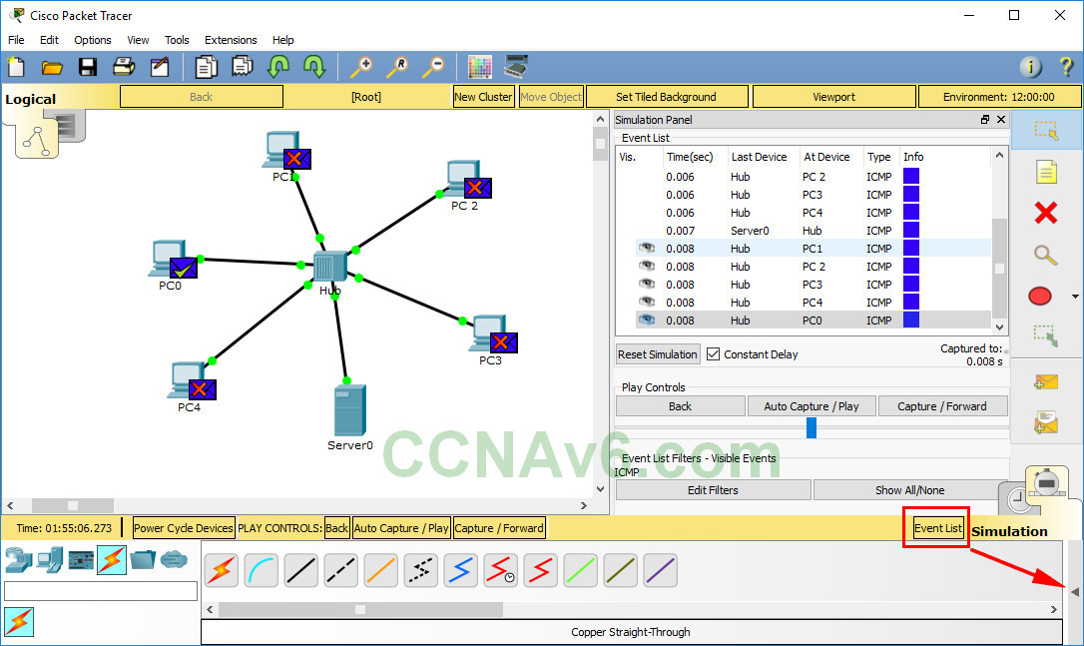

As already seen Hubs forward a frame they receive on all the outbound ports except the port through which it received the frame. When connected using hubs, the host devices share same bandwidth of the medium.

